WiFi tutorial

1. In the IEEE 802.11 CSMA/CA medium access mechanism, how does a transmitting node know if its frame experienced a collision or not? 2 marks)
2. List the different interframe spaces used in 802.11 access mechanism. What is the use of those interframe spaces? (5 marks)
3. Explain hidden node and exposed node problems with diagrams (4 marks)
4. Explain DS and RRTS message used in MACAW protocol with diagram (4 marks)
5. Explain MACA and MACAW mac protocols with proper diagrams (8 marks)
6. Discuss how MACAW solves the exposed node problem (4 marks)
7. Describe the four-frame exchange handshaking with proper diagram (6 marks)
8. Describe the physical layer technologies such as FHSS, DSSS and OFDM

(6 marks)

1. Consider a wireless network of 5 wireless nodes M, N, X, Y and Z as given in figure below. Node X is transmitting data to node Y using CSMA.

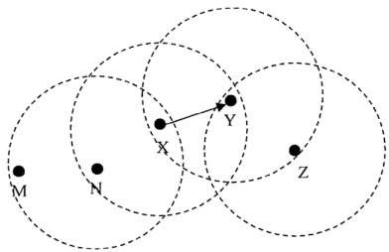

* 1. Which node causes hidden node problem?
  2. Which node causes exposed node problem?
  3. How can these problems be solved?

Provide suitable diagrams to explain your answers (8 marks)